Here is information about The 2026 China Trademark Annual Conference：
1、Venue of the Conference: Xiamen International Conference & Exhibition Center, No. 198 Huizhan Road, Siming District, Xiamen, Fujian, China.
For your convenience, the Chinese name and address are provided below:
Name in Chinese: 厦门国际会议展览中心
Address in Chinese: 福建省厦门市思明区会展路198号
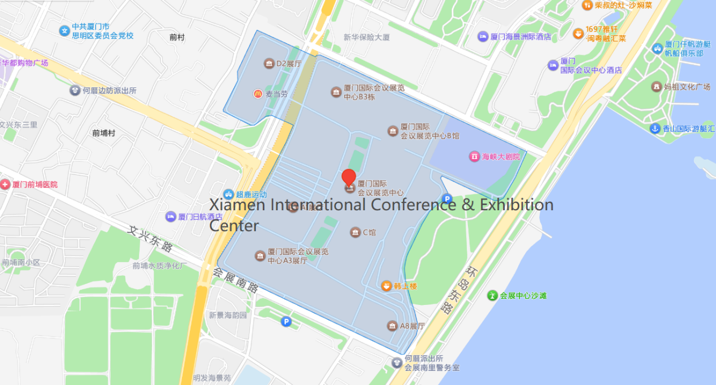

2、Cooperative hotels, the following is the address and contact information of the cooperative hotels.
（1）InterContinental Xiamen （厦门海景洲际酒店）
Address: No. 19, Lingshiguan Road, Siming District, Xiamen, Fujian;
Distance to Venue: 1.9km
Website: https://www.ihg.com.cn/intercontinental/hotels/cn/zh/xiamen/xmnlr/hoteldetail
Email: reservation@icxiamen.com
Contact person: Jing WEN +86 13684200297

（2）Shangri-La Hotel, Xiamen （厦门香格里拉酒店）
Address: No. 168, Taidong Road, Guanyinshan International Business Center, Siming District, Xiamen, Fujian
Distance to Venue: 4.5km
Website: https://www.shangri-la.com/cn/xiamen/shangrila/
Contact person: Jingze ZHANG +86 18804356356
Hotel landline: 0592-8385888
Shangri-La Hotel Sales: ellen.zhangjz@shangri-la.com
Shangri-La Reservations: restem.slxm@shangri-la.com

3、 Booth, Additionally, a separate expo will take place alongside the annual conference. We are offering our guests a 3m×3m booth (9 sqm) for RMB 8,000. Should you wish to book, please get in touch.

